8. nbm 2
8. Distribution Resource Planning 8-1
FACILITY STOCK COUNTS 8-1
Adding Stock Counts 8-2
Adding Products to Facility Stock Counts 8-3
Deleting Products from Facility Stock Counts 8-3
Viewing Facility Stock Counts 8-4
METHOD 1 8-4
METHOD 2 8-4
METHOD 3 8-4
Editing Facility Stock Counts 8-4
Editing Stock Count Dates 8-5
Deleting Facility Stock Counts 8-5
Delivery Personnel 8-5
Adding Delivery Personnel 8-5
Viewing Delivery Personnel 8-6
METHOD 1 8-6
METHOD 2 8-6
Editing Delivery Personnel 8-6
Deleting Delivery Personnel 8-6
Printing the Selected Delivery Person 8-7
DELIVERY VEHICLES 8-7
Adding Delivery Vehicles 8-8
Viewing Delivery Vehicles 8-9
METHOD 1 8-9
METHOD 2 8-9
Editing Delivery Vehicles 8-9
Deleting Delivery Vehicles 8-10
Printing the Selected Delivery Vehicle 8-10
DELIVERY ROUTES 8-10
Adding Delivery Routes 8-10
Assigning Facilities to Delivery Routes 8-11
Viewing Delivery Routes 8-12
METHOD 1 8-12
METHOD 2 8-12
Editing Delivery Routes 8-12
Deleting Delivery Routes 8-13
Printing the Selected Delivery Route 8-13
DELIVERY PLANNING 8-14
Adding Deliveries 8-14
Determining Need 8-15
Changing Desired Quantities 8-16
Auto-Filling 8-16
Confirming Deliveries 8-16
Viewing Deliveries 8-17
METHOD 1 8-17
METHOD 2 8-17
METHOD 3 8-17
Printing the Selected Delivery 8-18
Previewing Shipment Reports 8-18
Printing Shipment Reports Without Previewing 8-19
Editing Deliveries 8-19
Assigning Delivery Personnel 8-19
Setting Delivery Dates 8-19
Completing Deliveries 8-20
Deleting Deliveries 8-20

FILE IS C:\WORK\SCMgr\Documents\new manual\SCMgr-sec7.doc

nbm

This is an information page. Do not include it in the finished manual.

Distribution Resource Planning
- In the main menu, click the DRP option.
 | The DRP option will be visible only if the DRP Module is checked in the System Configuration form. (See Section 4 – System Configuration for more information.

FACILITY STOCK COUNTS
The Facility Stock Count form lets you record stock levels at each facility. Reported stock levels are used to estimate current stock balances.

- Click the Facility Stock Count option.

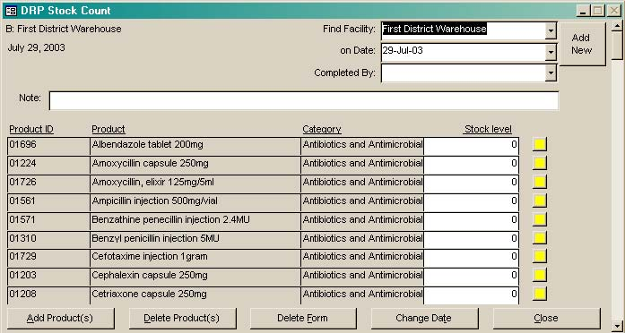
Figure 8-1 -- Facility Stock Count formThe Facility Stock Count form (Figure 8-1) is displayed.

Adding Stock Counts
- Click on the arrow next to the Find Facility field, select a facility from the pull-down menu, and click the left mouse button.

- Click the On Date field and type the date that the stock level was collected.
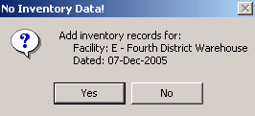
Figure 8-2 – Confirmation message

- Click Add New.

A confirmation message (Figure 8-2) is displayed, asking you to confirm the new record.

- Click Yes to add a stock count record.

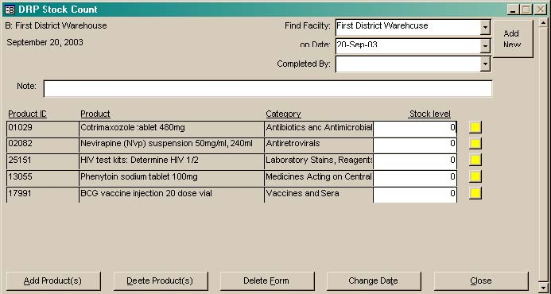
Figure 8-3 – Blank Facility Stock Count formA facility stock count record (Figure 8-3) is created, listing products distributed by the selected facility.

- Click on the arrow next to the Completed By field, select from the pull-down menu the name of the person who reported the stock count, and click the left mouse button.

- Click the Note field and type a note for the stock count record if applicable.

- For each product reported, click the Stock Level field and type the reported stock level.

You can enter notes on any product by clicking on the note icon to the right of the Stock Level field.

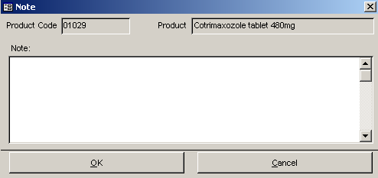
- Figure 8-4 – Note windowClick the Note icon to the right of the Stock Level field to open the Note window for the selected product.

The Note window (Figure 8-4) is displayed.

- Type a note and click OK or close the Note window to return to the Facility Stock Count form.

- Click Cancel to close the Note window without adding notes.

Adding Products to Facility Stock Counts
- Click the Add Product(s) button.

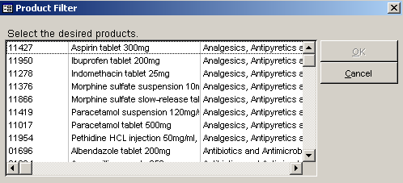
Figure 8-5 – Product Filter windowThe Product Filter window (Figure 8-5) is displayed, listing all products in Supply Chain Manager.

- Click one or more products to add.

- Click OK to close the Product Filter window.

- Click Cancel to close the window without adding products.

The selected product(s) appear(s) on the Stock Count form.

Deleting Products from Facility Stock Counts
Products can be deleted from the stock count of the selected facility as follows—

- Click Delete Product(s).

The Product Filter window (Figure 8-5 above) is displayed, listing all products distributed by the facility’s type.

- Click one or more products you wish to delete.

- Click OK to delete the selected products.

- Click Close to return to the Facility Stock Count record.

Viewing Facility Stock Counts

METHOD 1
- Click on the arrow next to the Find Facility field, select a facility from the pull-down menu and click the left mouse button to display the current stock count record for that facility.

METHOD 2
- Click on the arrow next to the On Date field, select a date from the pull-down menu and click the left mouse button to display the stock count record for the selected facility.

METHOD 3
- Click on the arrow next to the Find Facility field, select a facility from the pull-down menu and click the left mouse button.

- Click on the arrow next to the On Date field, select a date from the pull-down menu and click the left mouse button.

The facility’s stock count on the selected date is displayed.
 | If the facility has more products than can be displayed on the screen, click the vertical scroll bar to view additional products.

Editing Facility Stock Counts
- Select the stock count record you wish to edit.

- Click the field you wish to change and type your changes.

- Click Close when you finish editing the stock count record.

Editing Stock Count Dates
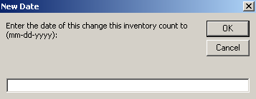
- Figure 8-6 – New Date formClick Change Date.

The New Date form (Figure 8-6) is displayed.

- Type a date and click OK.

Deleting Facility Stock Counts
- Click Delete.
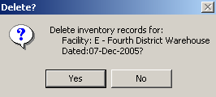
Figure 8-7 – Delete confirmation message

A confirmation message (Figure 8-7) is displayed, asking you to confirm to delete.

- Click Yes to delete the selected record.

- Click No to cancel.

Delivery Personnel
- In the DRP menu, click the Personnel option.

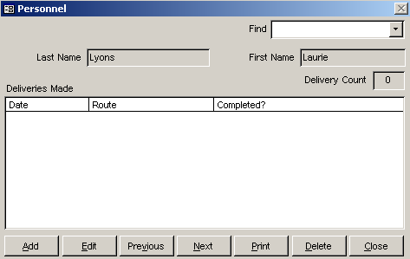
Figure 8-8 – Personnel formThe Personnel form (Figure 8-8) is displayed.

Adding Delivery Personnel
- Click Add.

A blank Personnel form (Figure 8-9) is displayed as shown on the following page.

- Type the delivery person’s last name and press <Enter>.

- Type the delivery person’s first name.

- Click Save.

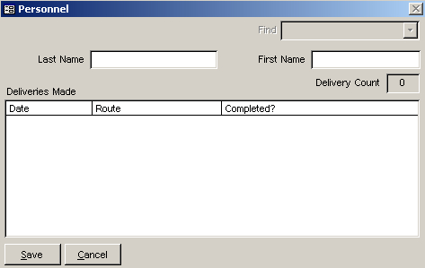
- Figure 8-9 – Blank Personnel formRepeat steps 1-4 to add more delivery personnel.

- Click Close when you finish adding personnel.

Viewing Delivery Personnel

METHOD 1
- Click on the arrow next to the Find field, select a delivery person from the pull-down menu, and click the left mouse button to display the delivery person’s first and last name.

- Click Close when you finish viewing delivery personnel.

METHOD 2
- Click Next to display the next delivery person.

- Click Previous to display a previously displayed delivery person.

- Click Close when you finish viewing delivery personnel.

Editing Delivery Personnel
- Select the delivery person whose name you wish to edit.

- Click Edit.

- Click on the Name field you wish to edit and type your changes.

- Click Save.

- Repeat steps 1-4 to edit additional delivery personnel.

- Click Close when you finish editing delivery personnel.

Deleting Delivery Personnel
- Select the delivery person you wish to delete.

- Click Delete.

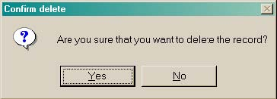
Figure 8-10 – Delete confirmation messageA confirmation message (Figure 8-10) is displayed, asking you to confirm the delete.

- Click Yes to delete the selected delivery person.

- Repeat steps 1-3 to delete additional delivery personnel.

- Click Close when you finish deleting personnel.

Printing the Selected Delivery Person
- Select the delivery person whose record you wish to print.

- Click Print to create a report for the selected person.

- Click Close when you finish printing delivery personnel records.

DELIVERY VEHICLES
- In the DRP menu, click the Vehicles option.

The Delivery Vehicles form (Figure 8-11) is displayed.
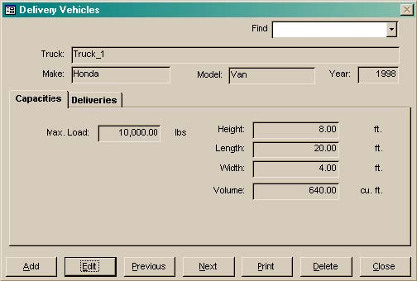
Figure 8-11 – Delivery Vehicles form

Adding Delivery Vehicles
- Click Add.

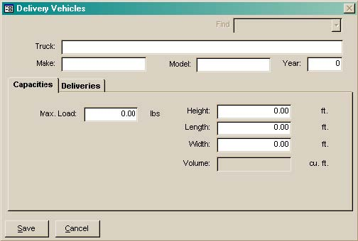
Figure 8-12 – Blank Delivery Vehicles formA blank Delivery Vehicles form (Figure 8-12) is displayed.

The Truck field lets you enter a brief description of the delivery vehicle (example: Half-ton pickup).

- Type a brief description of the delivery vehicle and press <Enter>.

- Type the vehicle’s manufacturer (example: Toyota) and press <Enter>.

- Type the vehicle’s model (example: Hilux) and press <Enter>.

- Type the four-digit year the vehicle was made.

- Click the Max. Load field, type the maximum load the vehicle can carry and press <Enter>.

 | The following fields apply to the size of the vehicle's cargo area and not the size of the vehicle itself.
- Type the cargo area’s height and press <Enter>.

- Type the cargo area’s length and press <Enter>.

- Type the cargo area’s width and press <Enter>.

The system calculates the cargo area’s volume and displays the calculated value in the Volume field.

- Click Save.

- Repeat steps 1-10 to add more delivery vehicles.

- Click Close when you finish adding delivery vehicles.

Viewing Delivery Vehicles

METHOD 1
- Click on the arrow next to the Find field, select a vehicle from the pull-down menu and click the left mouse button.

- Click the Deliveries tab to view delivery routes the vehicle has completed or is scheduled to make.

- Click Close when you finish viewing delivery vehicles.

METHOD 2
- Click Next to display the next vehicle.

- Click Previous to display the previously displayed vehicle.

- Click the Deliveries tab to view delivery routes the vehicle has completed or is scheduled to make.

- Click Close when you finish viewing delivery vehicles.

Editing Delivery Vehicles
- Select the delivery vehicle you wish to edit.

- Click Edit.

- Click on the field you wish to change and type your changes.

- Click Save.

- Click Close when you finish editing delivery vehicles.

Deleting Delivery Vehicles
- Select the delivery vehicle you wish to delete.

- Click Delete.
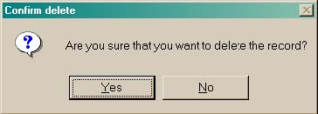
Figure 8-13 – Delete confirmation message
A confirmation message (Figure 8-13) is displayed, asking you to confirm the delete.

- Click Yes to delete the record.

- Repeat steps 1-3 to delete additional delivery vehicles.

- Click Close when you finish deleting delivery vehicles.

Printing the Selected Delivery Vehicle
- Click Print to create a report for the selected vehicle.

DELIVERY ROUTES
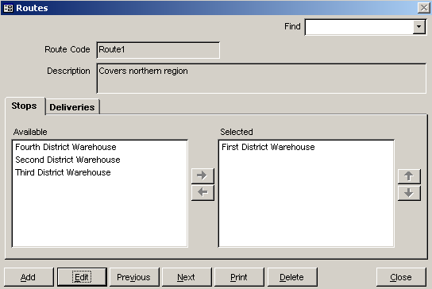
Figure 8-14 – Delivery Routes formIn the DRP menu, click the Delivery Routes option.

The Delivery Routes form (Figure 8-14) is displayed.

Adding Delivery Routes
- Click Add.

A blank Delivery Routes form (Figure 8-15) is displayed as shown on the following page.

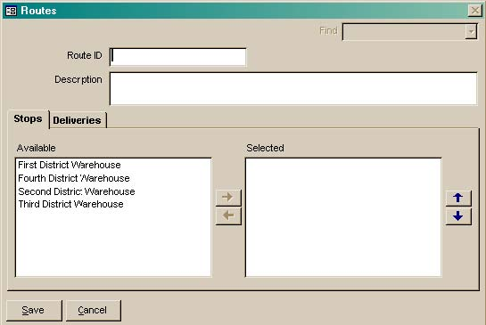
- Figure 8-15 – Blank Delivery Routes formType a unique code and press <Enter>.

- Type a description for the route.

Assigning Facilities to Delivery Routes
- In the Available area, click the facility or facilities you wish to assign to the route. Select multiple facilities by pressing the <Ctrl> or <Shift> key while clicking on each facility.

After selecting all facilities to be assigned to the route,

- Click the right arrow to move the facilities to the Selected window.

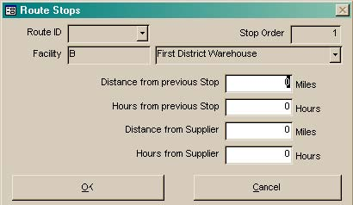
Figure 8-16 – Route Stops formA Route Stops form (Figure 8-16) is displayed for each facility you selected.

- For each facility, click the Distance From Previous Stop field and enter the distance to this stop from the previous one.

- Click the Hours From Previous Stop field and enter the amount of time (in hours) it takes to drive from this stop to the previous one.

- Click the Distance From Supplier field and type the distance from the facility to its supplier.

- Click the Hours From Supplier field and type the amount of time (in hours) it takes to drive from the facility to its supplier.

- Click OK to return to the delivery route record.

- Repeat steps 1-7 to assign additional facilities to the route.

- Click Save.

- Click Close when you finish adding delivery routes.

You can change the position of facilities in the Selected window of the Stops tab as follows—

- Select the facility you wish to move.

- Click the up arrow or down arrow to change the facility’s position in the route.

- Click Save.

Viewing Delivery Routes

METHOD 1
- Click on the arrow next to the Find field, select a route from the pull-down menu, and click the left mouse button.

- Click on the Deliveries tab to view scheduled and completed deliveries for the selected delivery route.

- Click Close when you finish viewing delivery routes.

METHOD 2
- Click Next to display the next route.

- Click Previous to display a previously displayed route.

- Click the Deliveries tab to view scheduled and completed deliveries for the selected delivery route.

- Click Close when you finish viewing delivery routes.

Editing Delivery Routes
- Select the route you wish to edit.

- Click Edit.

- Click the field you wish to change and type your changes.

To add a facility to the route, do the following—
- In the Available window, click the facility you wish to add to the route. Click on the right arrow to move the facility to the Selected window.

To remove a facility from the route, do the following—
- In the Selected window, click the facility you wish to remove from the route. Click on the left arrow to move the facility to the Available window.

You can change the position of facilities in the Selected window of the Stops tab as follows—
- In the Selected window, click the facility whose position you wish to change. Click on the up arrow or down arrow to change its position.

- Click Save.

- Click Close when you finish editing delivery routes.

Deleting Delivery Routes
- Select the delivery route you wish to delete.

- Click Delete.
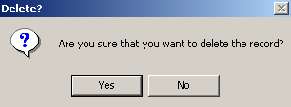
Figure 8-17 – Delete confirmation message
A confirmation message (Figure 8-17) is displayed, asking you to confirm the delete.

- Click Yes to delete the selected record.

- Repeat steps 1-3 to delete additional delivery routes.

- Click Close when you finish deleting delivery routes.

Printing the Selected Delivery Route
- Select the delivery route you wish to print.

- Click Print to create a report for the selected delivery route.

After the report is created, its first page is displayed.

- Click Print to print the report.

- Click Close on the Print Menu to return to the Delivery Routes form.

- Click Close when you finish printing delivery routes.

DELIVERY PLANNING
The Delivery Planning option lets you assign drivers and vehicles to delivery routes. This option also lets you schedule deliveries and then assign vehicles and personnel to them.

- In the DRP menu, click the Delivery Planning option.

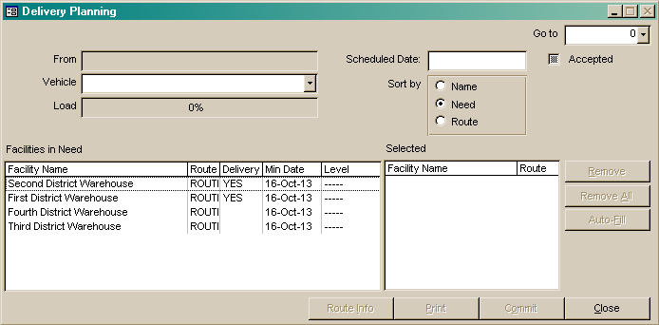
Figure 8-18 – Delivery Planning formThe Delivery Planning form (Figure 8-18) is displayed.

Adding Deliveries
- Click on the arrow next to the Go To field, select <NewDelivery> from the pull-down menu, and click the left mouse button.

Facilities within the distribution network are displayed in the Facilities In Need window (Figure 8-19). These facilities are listed by need. You can change the sort order as follows—
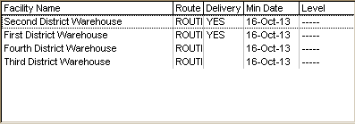
Figure 8-19 – Facilities in Need list

- Click the Name option in the Sort By field to sort by name.

- Click the Route option in the Sort By field to sort by route.

Before you plan a delivery, you must select a vehicle for the delivery.

- Click on the arrow next to the Vehicle field, select a vehicle from the pull-down menu, and click the left mouse button.

After you select a vehicle, you can select the facilities to which it will distribute products.

- Double-click a facility in the Facilities In Need window.

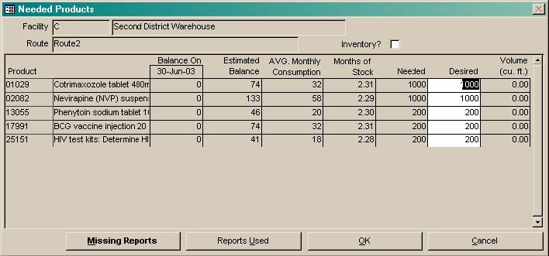
Figure 8-20 – Needed Products formThe Needed Products form (Figure 8-20) is displayed.

- Click the Inventory checkbox if a physical inventory must be taken when products are delivered.

Determining Need
Need is usually determined by Supply Chain Manager based on data recorded in the Product Tracking form (see Adding Product Tracking Records on page 6-1 for more information). From within the Deliveries form, you can view the lists of reports used for calculating need and any missing reports.
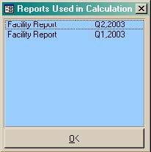
Figure 8-21 – Report Used in Calculation window
- Click Reports Used to view the list of reports that were used to calculate the selected facility’s need.

The Reports Used In Calculation window (Figure 8-21) is displayed.

- Click OK to close the window.

The Missing Reports button shows the reports that were not available for calculating need. If reporting is complete, this window should not display any reports.

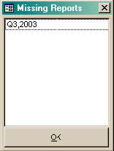
- Figure 8-22 – Missing Reports windowClick Missing Reports to display the reports not available for calculating need.

The Missing Reports window (Figure 8-22) is displayed.

If missing reports are listed, try to acquire the reports and record them in the Product Tracking form. Complete reporting will help ensure that the facilities are stocked according to plan.

- Click OK to close the window.

Changing Desired Quantities
You can change quantities of products to be delivered by changing the values in the Desired column.
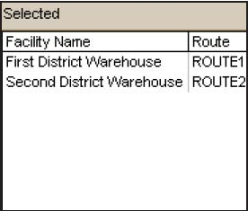
Figure 8-23 – Selected Facilities window
- Double-click the quantity you wish to change and type your changes.

- Repeat step 1 to edit the desired quantities for additional products.

- Click OK when you are finished changing desired quantities.

The facility is moved to the Selected window (Figure 8-23) and the percentage of the vehicles’s occupied cargo space is displayed in the Load field.

Auto-Filling
The Auto-Fill feature lets you plan a delivery route based on established delivery routes by selecting one facility and letting the DRP Module select the rest. The module selects all facilities on the same route as the facility you just selected.

This may overload the selected vehicle. If this happens—
- Click the arrow next to the Vehicle field, select a larger vehicle (if one is available) from the pull-down menu, and click the left mouse button.

Confirming Deliveries
After you add a delivery, you can confirm it as follows:

- Click Confirm.

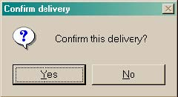
Figure 8-24 – Confirm Delivery windowA confirmation window (Figure 8-24) is displayed, asking you to confirm the delivery.

- Click Yes to confirm the delivery.

The Shipping Reports form (Figure 8-25) is displayed.

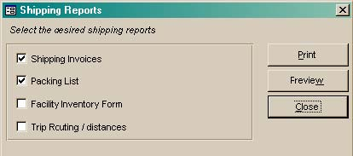
- Figure 8-25 – Shipping Reports formClick the checkbox to the left of each shipping report you wish to print.

- Click Preview to preview the reports before printing.

- Click Print to print the reports without previewing.

Viewing Deliveries

METHOD 1
- Click on the arrow to the right of the Go To field, select a route from the pull-down menu, and click the left mouse button.

- Repeat step 1 to view additional deliveries.

- Click Close when you finish viewing deliveries.

METHOD 2
- Click on the arrow next to the Find field, select a route from the pull-down menu, and click the left mouse button to display the selected route.

- Click Close when you finish viewing deliveries.

METHOD 3
- Click Next to display the next record.

- Click Previous to display the previously displayed record.

- Click Close when you finish viewing deliveries.

Printing the Selected Delivery
- Select the delivery you wish to print.

- Click Print.

The Shipping Reports form (Figure 8-25 on page 26) is displayed.

- Click the reports you wish to preview or print.

Previewing Shipment Reports
Use the Preview button to preview each report before you print it.

- Click Preview.

A preview window for each selected shipping report is displayed. The windows are layered and may appear as one window.

- Click Minimize to reduce the size of each window.

Each preview window is reduced and placed near the bottom of the screen (27).

- Figure 8-26 – Minimized shipping reportsClick Maximize to review each report.

The expanded preview window shows the first page of the report. This page may contain more data than your screen can display at one time.

- Use the vertical scroll bar to view the page from top to bottom.

- Use the horizontal scroll bar to view the page from left to right.

- Figure 8-27 – Navigation barUse the navigation bar (Figure 8-27) to view reports with multiple pages, one page at a time.

See Section 3 – Getting Started for more information on the scroll and navigation bars.

- Click Print to print the report.

- Click Close.

Printing Shipment Reports Without Previewing
You can print shipment reports without previewing them as follows—

- Select the delivery planning record you wish to print.

- Click Print to display the Shipping Reports form.

- Click the checkbox to the left of each report you wish to print.

- Click Print to print the reports.

After the reports are printed—

- Click Close.

Editing Deliveries
- Select the delivery you wish to edit.

- Click Edit.

Assigning Delivery Personnel
- Click the Personnel tab.

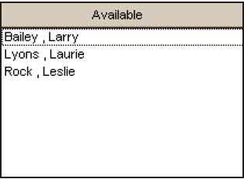
Figure 8-28 – Available Delivery personnel listAvailable delivery personnel are displayed in the Personnel window (Figure 7-30).

- Click the name of the person to assign to the selected delivery.

- Click Add to move the person to the Selected window.

- Click Save.

Setting Delivery Dates
- Select the delivery you wish to schedule.

- Click Edit.

- Type the start date in the Est. Date field.

- Click Save.

Completing Deliveries
After a delivery has been completed—

- Select the delivery that was completed.

- Click Edit.

- Click the Completed checkbox.

- Click Save.

Deleting Deliveries
- Figure 8-29 – Delete confirmation messageSelect the delivery you wish to delete.

- Click Delete.

A confirmation message (Figure 8-29) is displayed, asking you to confirm the delete.

- Click Yes to delete the selected record.

- Repeat steps 1-3 to delete additional deliveries.

- Click Close when you finish deleting deliveries.

